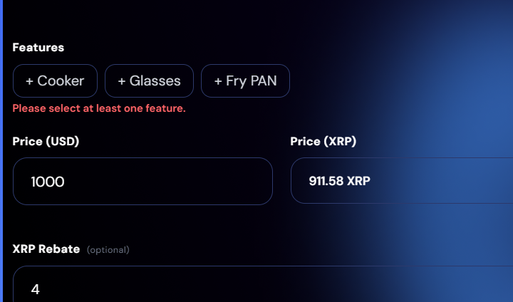

Features issue: without features selection we are unable to create listing.
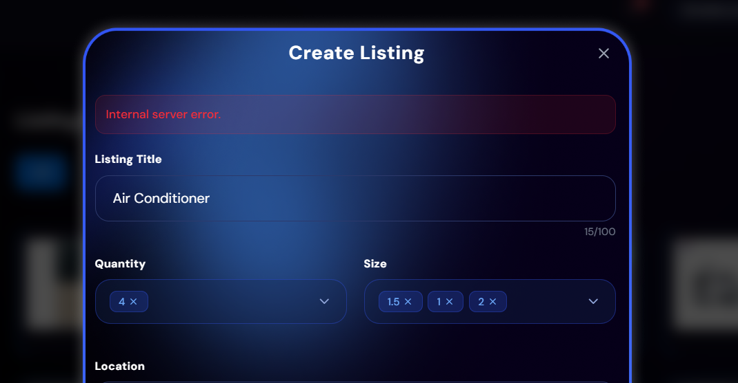

I’m unable to create listing in appliances.
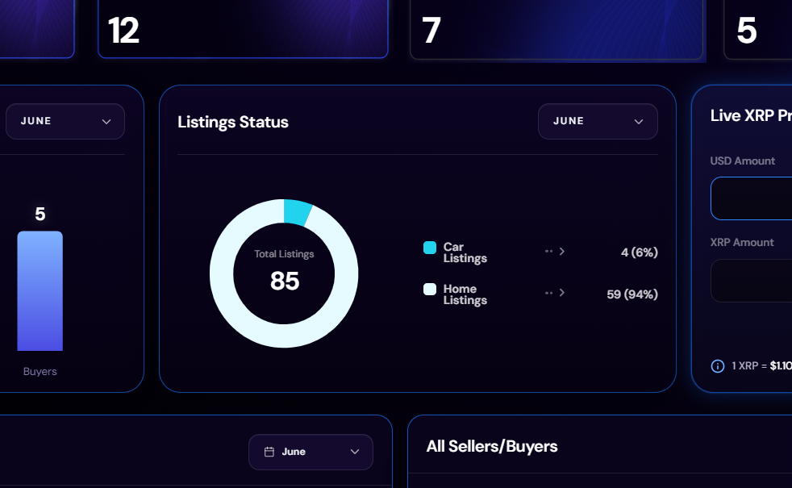
Admin panel’s round animation is different from Design and Seller side.
In General AC’s Listing is successfully created.
Push Notification didn’t appeared on admin.

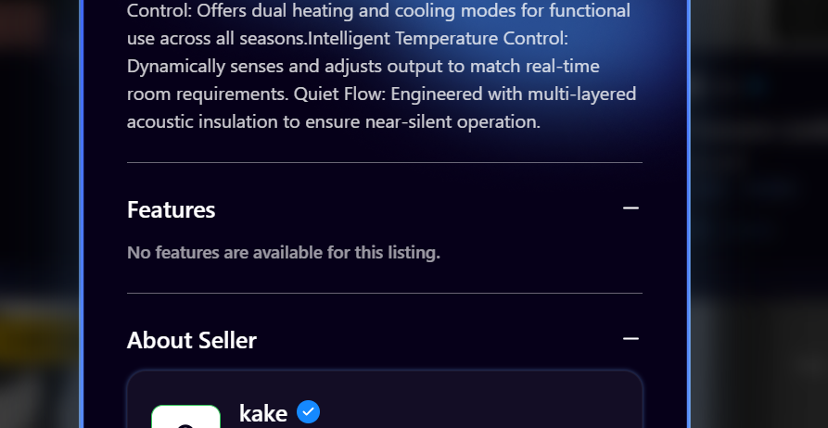
Features are not shown on the buyer side.

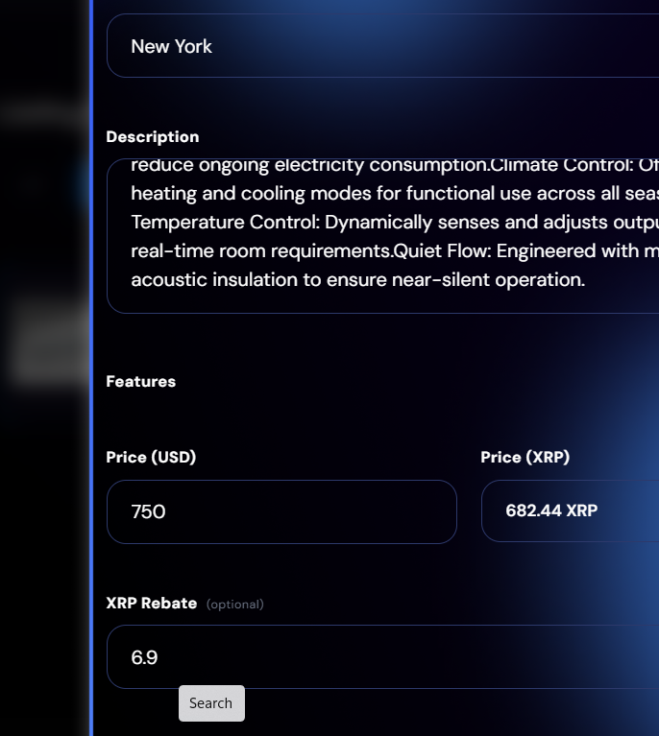

Features not visible in General – Acs.
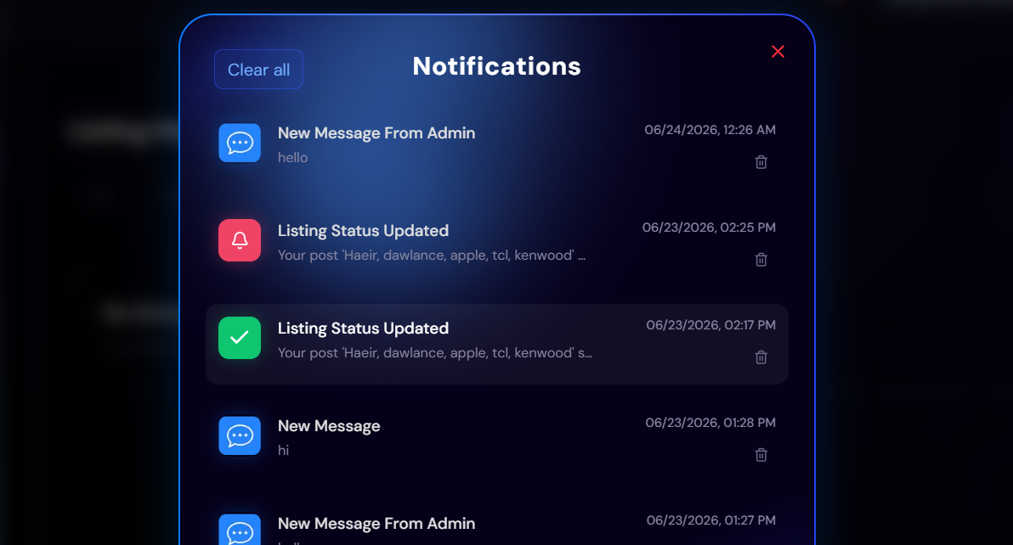

Latest suspended list from admin to the seller. It is populated on the second position not on the first.

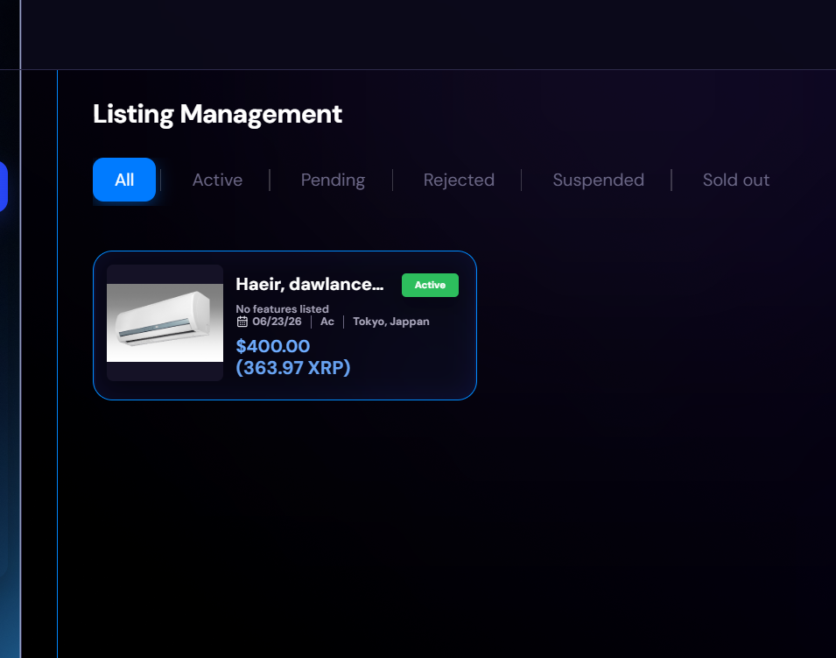
This is suspended by admin, but still it appears as active on the lisitng management “Seller”

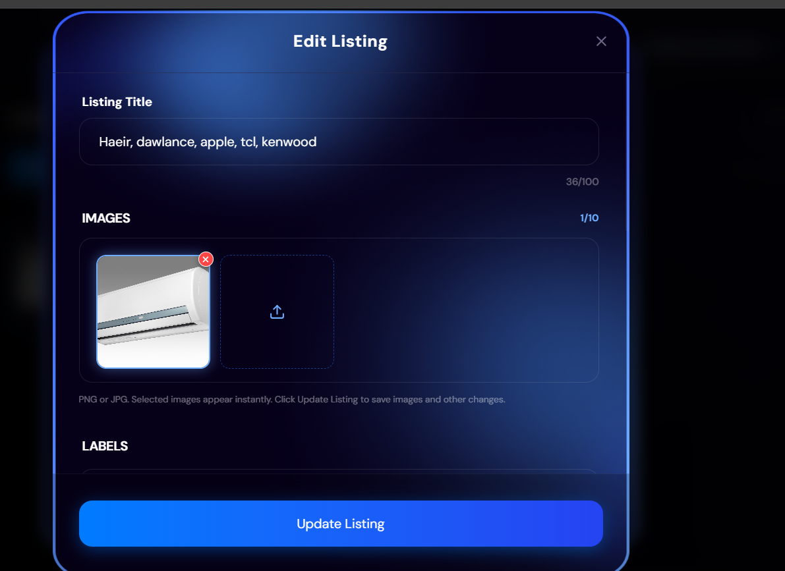
Form fields’ sequence appears as not consistent, The original card is different but in edit it goes like bottom to top.

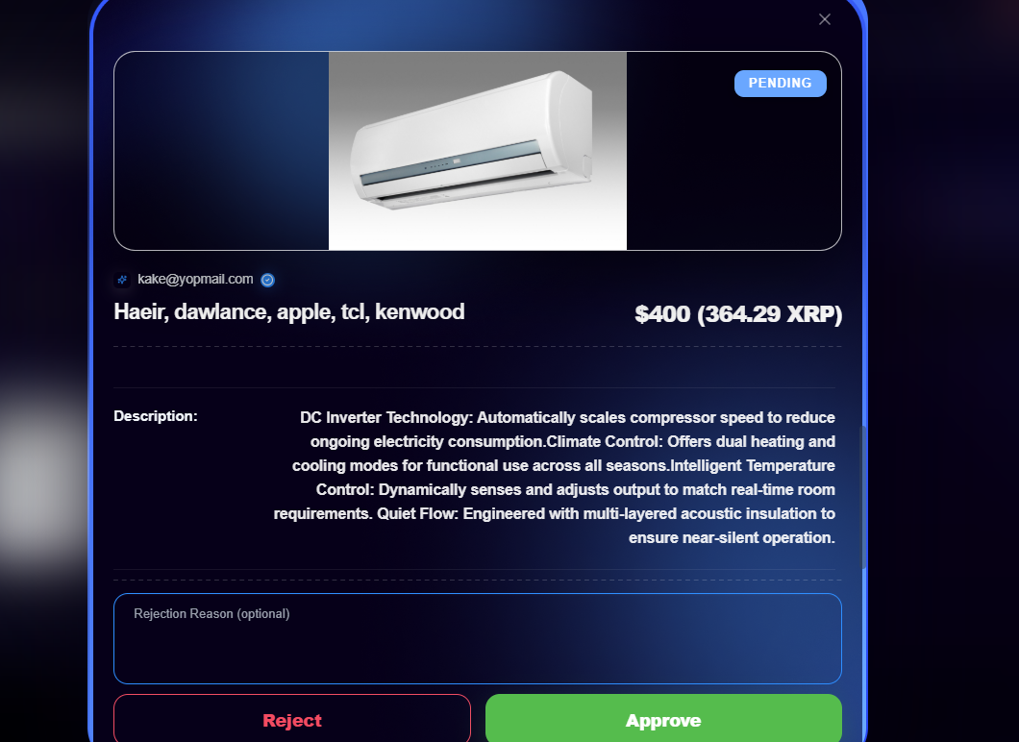
Decs data on admin panel appears on the right not on the left.

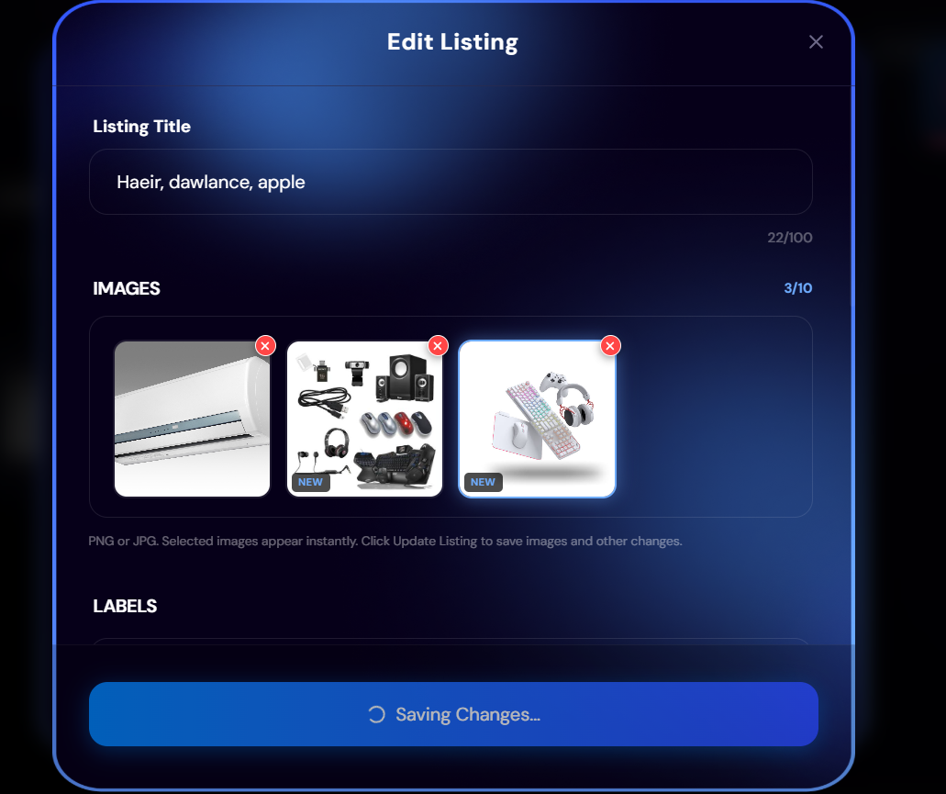
While editing listing, the listing is not updating

